**SL - Practical - 2**

**Name: Rishabh Jain**

**Branch & Sem: CSE - IV**

**Sec: A**

**Roll no.:54**

**AIM: To Design Event Registration Form, and display sample participant details in the table named" Event Registration Details" apply all table properties and CSS to the event registration form.**

**CODE :**

**Table.html**

<!DOCTYPE html>

<html lang="en">

<head>

    <meta charset="UTF-8">

    <meta http-equiv="X-UA-Compatible" content="IE=edge">

    <meta name="viewport" content="width=device-width, initial-scale=1.0">

    <title>Registration</title>

    <link rel="stylesheet" href="./Prac_02_Table.css">

</head>

<body>

    <div class="container">

    <div class="heading"> <b>Event Registration Details</b></div>

    <table>

        <tr>

            <th>Sr No </th>

            <th>Name </th>

            <th>Event </th>

            <th>Class </th>

            <th>B.TECH/M.TECH </th>

            <th>Paid </th>

            <th>Email </th>

            <th>Mobile </th>

        </tr>

        <tr>

<td>1.</td>

<td>Rishabh Jain</td>

<td>Pratishruti</td>

<td>4th sem</td>

<td>B.tech</td>

<td>yes</td>

<td>jainra_1@rknec.edu</td>

<td>7666137732</td>

        </tr>

        <td>2.</td>

<td>Prerna Chourasia</td>

<td>Polaris</td>

<td>4th sem</td>

<td>B.tech</td>

<td>yes</td>

<td>Prerna@rknec.edu</td>

<td>9235238516</td>

        <tr>

            <td>3.</td>

<td>Maitri Markandeywar</td>

<td>Manzar</td>

<td>4th sem</td>

<td>B.tech</td>

<td>yes</td>

<td>markandeywarmn@rknec.edu</td>

<td>9049238516</td>

        </tr>

<tr>

    <td>4.</td>

    <td>Prathmesh Kurve</td>

    <td>Manzar</td>

    <td>4th sem</td>

    <td>B.tech</td>

    <td>yes</td>

    <td>kurveap@rknec.edu</td>

    <td>7666133275</td>

</tr>

<tr>

    <td>5.</td>

    <td>Sahil Khune</td>

    <td>Pratishruti</td>

    <td>4th sem</td>

    <td>B.tech</td>

    <td>yes</td>

    <td>Sahil@rknec.edu</td>

    <td>9888838516</td>

</tr>

<tr>

    <td>6.</td>

    <td>Vinay Pillai</td>

    <td>Pratishruti</td>

    <td>4th sem</td>

    <td>B.tech</td>

    <td>yes</td>

    <td>Pillai@rknec.edu</td>

    <td>9563238516</td>

</tr>

<tr>

    <td>7.</td>

    <td>Justin bailey</td>

    <td>Aruni</td>

    <td>4th sem</td>

    <td>B.tech</td>

    <td>yes</td>

    <td>justin@rknec.edu</td>

    <td>8555238516</td>

</tr>

</table>

<div class="footer">

  <p>Would you like to register..........?</p>

  <a href="http://127.0.0.1:5500/form.html" target="_blank">Click here</a>

</div>

</div>

</body>

</html>

**Table.css**

body{

    font-family: Gill Sans, 'Gill Sans MT', Calibri, 'Trebuchet MS', sans-serif;

background-color: black;

background-image: url("party.jpg");

background-size: cover;

backdrop-filter: blur(5px);

}

.heading

{

    height: 80px;

    width:1000px;

    font-family: ('Gill Sans', 'Gill Sans MT', Calibri, 'Trebuchet MS', sans-serif);

    font-size : 50px;

*/*  background-color: burlywood;*/*

    text-align: center;

    color:rgb(39, 6, 67);

  padding-top: 50px;

  text-shadow: 0 0 3px #4a3651;

}

a :hover{

color:rgb(12, 12, 12);

}

table{

    margin-top: 30px;

    margin-left: 40px;

    color: black;

    border-collapse:collapse;

    border:solid;

 height: 400px;

    border-color:rgb(182, 148, 160);

    text-align: center;

}

tr:hover{

    background-color: darkslateblue;

    color: beige;

    opacity: 0.5;

}

th{

    padding: 20px;

    background-color:rgb(182, 148, 160);

}

.footer

{

    margin-top: 50px;

    text-align: center;

    font-size: 20px;

}

.container

{

    height: 700px;

    width :1000px;

text-align: center;

    margin-left: 200px;

    color:rgb(39, 6, 67);

    background-color: rgb(216, 215, 223);

    margin-top: 50px;

}

table, th, td {

    border: 1px solid black;

  }

**Form.html**

<!DOCTYPE html>

<html lang="en">

<head>

    <meta charset="UTF-8">

    <meta http-equiv="X-UA-Compatible" content="IE=edge">

    <meta name="viewport" content="width=device-width, initial-scale=1.0">

    <title>form</title>

    <link rel="stylesheet" href="./Prac_02_Form.css">

</head>

<body>

    <div class="page">

<div class="heading">

    <p>Event Registration</p>

</div>

<div class="left">

    <form action="" class="one">

        <label>First name: <input type="text"></label><br>

        <br>

        <label for="">Last name: <input type="text"></label><br>

        <br>

        <label for="">College: <input type="text"></label><br>

        <br>

        <label for="">Department: <input type="text"></label><br>

        <br>

        <textarea name="text" id="txt" cols="30" rows="10">Describe Yourself.......</textarea><br>

        <br>

        <label for="">Email: <input type="email"></label>

        <br>

        <br>

        <label for="">Phone: <input type="text"></label><br>

        <br>

        <label for="">Gender: Male <input type="radio" name="genders"> Female<input type="radio" name="genders"></label><br>

        <br>

        <label for="">Addresses: <input type="text"></label>

        <br>

        <br>

        </form>

</div>

<div class="right">

<form action="" class="two">

<label for=""> City:

    <select name="city" id="City">

        <option value=""></option>

        <option value="">Mumbai</option>

        <option value="">Nagpur</option>

        <option value="">Amravati</option>

        <option value="">Pune</option>

        <option value="">Akola</option>

        <option value="">chandrapur</option>

        <option value="">warda</option>

        <option value="">yavatmal</option>

        <option value="">Bandara</option>

        <option value="">Bilaspur</option>

        </select>

</label>

 <br><br>

<label for=""> State:

    <select name="State" id="State">

        <option value=""></option>+

        <option value="">Goa</option>

        <option value="">Maharshtra</option>

        <option value="">Andra Pradesh</option>

        <option value="">Tamil Nadu</option>

        <option value="">Karnataka</option>

        <option value="">Madhya Pradesh</option>

        <option value="">Bihar</option>

        <option value="">Delhi</option>

        <option value="">Uttar Pradeh</option>

        <option value="">Rajasthan</option>

        </select>

</label>

<br> <br>

<label for=""> Events:

<br>

<input type="checkbox">

<label for="">Manzar</label>

<br>

<input type="checkbox">

<label for="">Polaris</label>

<br>

<input type="checkbox">

<label for="">Pratishuti</label>

<br>

<input type="checkbox">

<label for="">Aruni</label>

</label>

<br><br>

<label for="">Amount paid: <input type="text"><label>

    <br>

    <br>

  <label for=""> Transaction: <input type="text"></label>

  <br>

  <br>

            <label for="">Professional: <br><input type="checkbox">CSE <br>

                <input type="checkbox">IEEE <br>

                <input type="checkbox">ISTE <br>

                <input type="checkbox">IETE

            </label>

           <br><br>

           <br>

           <br>

            <button class="submit">Submit</button>

            <button class="reset"><a href="http://127.0.0.1:5500/form.html">Reset</a></button>

            <button class="ok">Ok</button>

</form>

</div>

 </div>

</div>

</body>

</html>

**Form.css**

body{

font-family: Gill Sans, 'Gill Sans MT', Calibri, 'Trebuchet MS', sans-serif;

background-image: url("./b1.jpeg");

background-size: cover;

backdrop-filter: blur(5px);

}

.page{

background-color: rgb(216, 215, 223);

    height: 800px;

    width: 800px;

 padding-top: 5px;

    margin-left: 270px;

    margin-top: 50px;

}

.heading

{

    text-shadow: 0 0 3px #4a3651;

    height: 50px;

    width:500px;

    font-family: Gill Sans, 'Gill Sans MT', Calibri, 'Trebuchet MS', sans-serif;

    font-size: 60px;

    border-color:darkolivegreen;

    color:rgb(39, 6, 67);

    text-align: center;

    margin-left: 150px;

    margin-top: 50px;

    vertical-align:middle;

padding-bottom: 50px;

}

.left

{

background-color: rgb(216, 215, 223);

height: 600px;

width: 50%;

float: left;

font-size: 20px;

}

.right

{

background-color: rgb(216, 215, 223);

    width: 50%;

    float: right;

    font-size: 20px;

}

form

{

    padding-top: 30px;

padding-left: 70px;

}

button

{

border: solid;

border-color: black;

border-width: 2.5px;

background-color: beige;

width: 65px;

height: 30px;

}

.submit

{

   background-color:green;

   color: white;

}

.ok

{

    background-color: blue;

    color: white;

}

.reset

{

    border-color: red;

    border-width: 2.5px;

    color: rgb(13, 13, 13);

}

**OUTPUT:**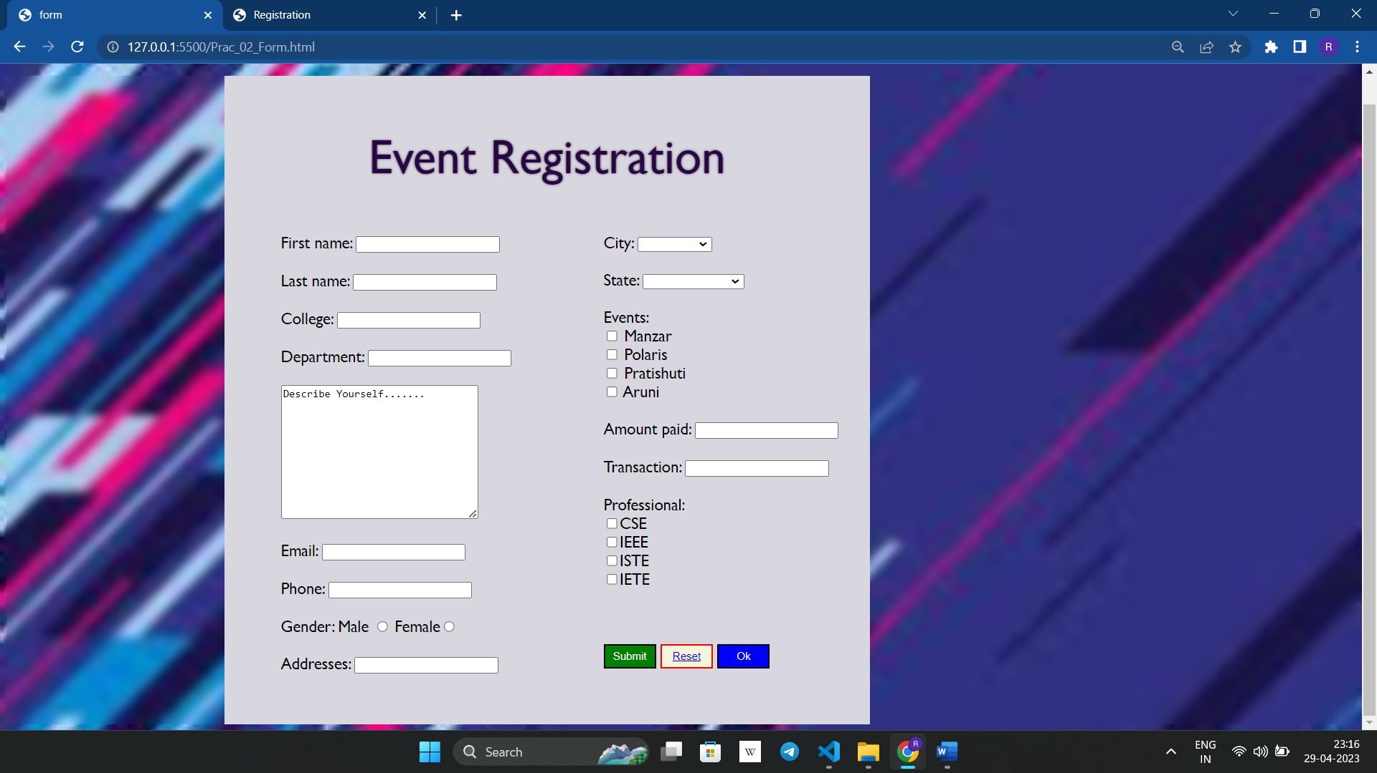

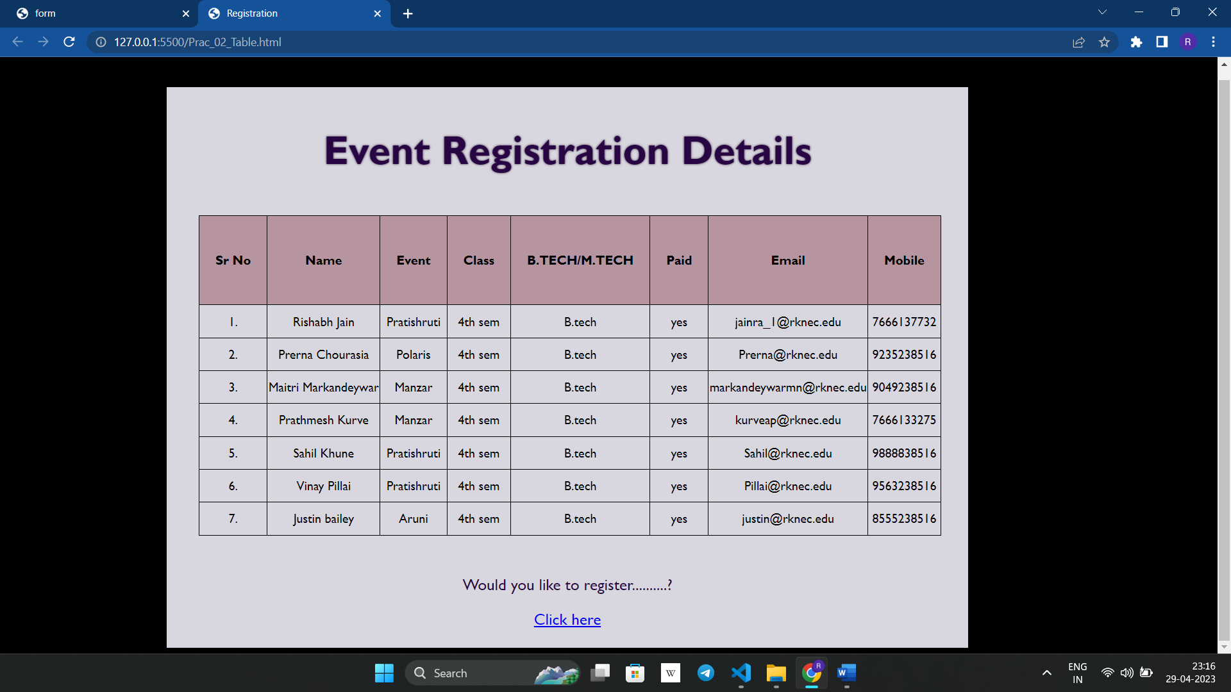

**Conclusion: In this practical, we learnt how to implement**

**basic HTML tags &amp; various CSS properties &amp; attributes. To design a static web page that has “Event Registration form” .Also, to make a well-detailed table that contains the registration of the participants who have registered for the events.**